

Forefront Asset Management, LLC Monthly Newsletter
Friday, July 11th, 2025
FOR MARKET CLOSE — July 10th, 2025

U.S. Equity Market Assessment and Economic Outlook

Yesterday, we had our monthly client webinar. Of particular note, we discussed the dichotomy that exists between the economy and the markets. Currently, we’re seeing consumer sentiment at levels where historically we’re already in a recession. We’re seeing house prices at levels above the CPI indicative of environments that generally lead to recessions (in other words, the bubble pops and prices fall). We’re seeing a Federal Government spending money at a pace that is generally only seen when the economy is already in a recession. Despite the negative backdrop, investors are buying everything in the market and equity allocation across the board is at lofty levels. In other words, the majority of investors are complacent and have no fear of losing money. This is classic “buy the dip” mentality because “the markets generally come back pretty quick.” As of today, all three trends (short, intermediate and long) in the market are positive. This is clearly bullish market behavior despite negative macro trends with the consumer.

Market Technical Indicators

Long Term Bull-Bear Indicator (Years)

Status: POSITIVE

Quarterly Timeframe Indicator (Monthly to Quarterly)

Status: POSITIVE

Shorter Timeframe Indicator (Weeks to Months)

Status: POSITIVE

THE COMPLETE PICTURE // READING THE INDICATORS

THREE INDICATORS ACROSS THREE TIMEFRAMES

- Yearly Trend Indicator — Positive since 6/10/25
- Quarterly Trend Indicator— Positive since April 1st, 2023
- Short term Trend Indicator—Positive since May 12th, 2025

When ALL the indicators are POSITIVE, we read the market as being in a BULL MARKET STATUS.
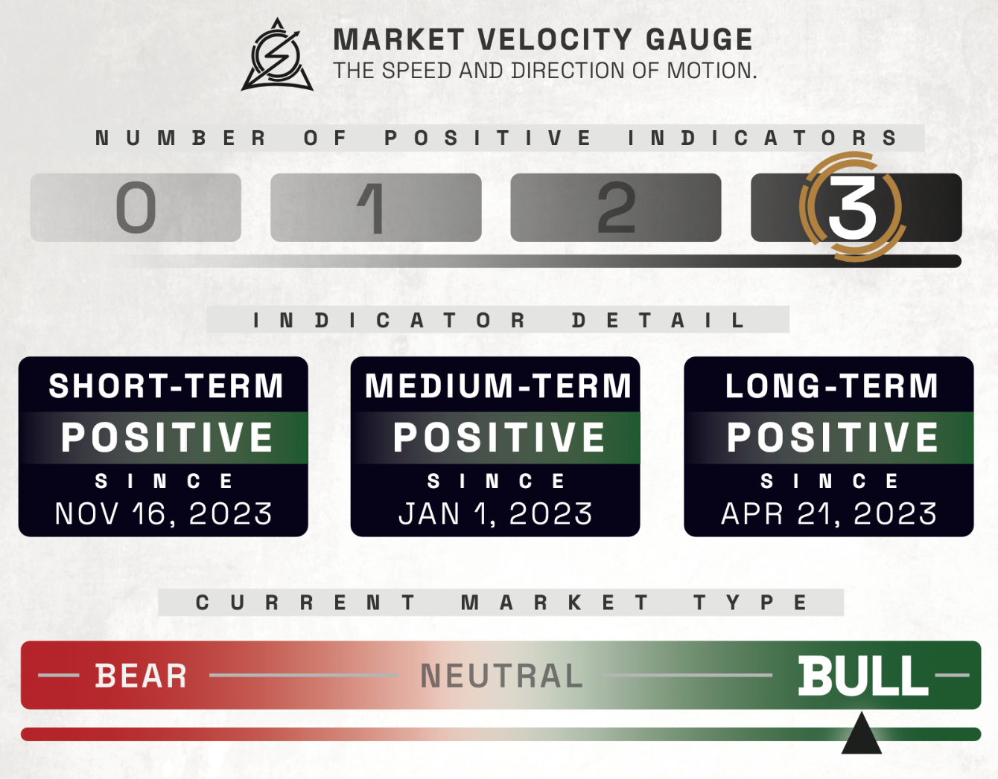

THIS MONTH’S ECONOMIC NEWS

U.S. MARKET OVERVIEW
Markets continue HIGHER
Stocks remain at all-time highs:
Major U.S. stock indexes ended the holiday-shortened month higher, with the S&P 500 Index and Nasdaq Composite closing at record highs for the second consecutive week. Smaller-cap indexes led the gains, as the S&P Midcap 400 rose 2.85% and the Russell 2000 climbed 3.52%, followed by a 2.30% advance in the Dow Jones Industrial Average. U.S. markets closed early Thursday and remained shut on Friday for the Independence Day holiday, resulting in several quiet trading sessions. The week’s focus was largely on the Trump administration’s reconciliation bill, which narrowly passed the Senate last Tuesday and the House on last Thursday, while trade developments also captured attention, including President Trump’s announcement of a trade deal with Vietnam on Wednesday and remarks about negotiations with other trade partners ahead of the July 9 tariff deadline, when the 90-day suspension of reciprocal tariffs is set to expire As of today, he’s extended the deadline to August 1st. .
.

THIS MONTH’S ECONOMIC NEWS FOR THE US

Unemployment continues to fall:
U.S. job growth remained resilient in June, with the Labor Department reporting 147,000 jobs added—beating economists’ expectations and surpassing May’s upwardly revised 144,000—while the unemployment rate edged down to 4.1% and average hourly earnings rose 0.2% month over month. The stronger-than-expected jobs report contrasted with Wednesday’s disappointing data from ADP, which showed a surprise 33,000 decline in private payrolls, the first negative reading since March 2023, attributed to employers’ hesitancy to hire or replace workers. Separately, job openings climbed to 7.8 million in May, the highest since November, led by gains in accommodation, food services, and finance, while initial jobless claims for the week ended June 28 fell to 233,000. In other economic data, the ISM’s manufacturing PMI indicated contraction for a fourth month in June at 49%, though the pace of decline slowed thanks to improvements in inventories and production, while the services sector rebounded to expansion with a PMI of 50.8% driven by stronger business activity and new orders; meanwhile, the Prices Index eased slightly but stayed elevated at 67.5%, marking the seventh consecutive month above 60% and signaling persistent price pressures.

INTERNATIONAL MARKETS
Europe
Over the four days ended Thursday, the pan-European STOXX Europe 600 Index was roughly flat in local currency terms, with major European stock indexes delivering mixed returns: France’s CAC 40 rose 0.82%, Italy’s FTSE MIB advanced 0.51%, Germany’s DAX slipped 0.41%, and the UK’s FTSE 100 gained 0.28%. On the economic front, eurozone headline inflation in June ticked up to the European Central Bank’s (ECB’s) 2.0% target from May’s eight-month low of 1.9%, while core inflation held steady at 2.3% and services inflation, closely watched by policymakers, edged up to 3.3% from 3.2%. Meanwhile, the euro area’s labor market remained robust, with the seasonally adjusted unemployment rate rising slightly to 6.3% in May from April’s record low of 6.2%, but still below 6.4% a year earlier. Speaking at the ECB’s annual forum in Sintra, Portugal, ECB President Christine Lagarde acknowledged reaching the 2% inflation target but cautioned that more time and data were needed before confirming that inflation risks had fully subsided, warning: “Our work is not done, and we need to remain vigilant,” which dampened hopes for imminent further rate cuts.

Japan
Japan’s stock markets declined over the month through Thursday, with the Nikkei 225 falling 0.91% and the TOPIX down 0.41%, as investor sentiment was weighed down by signs of stalled progress in U.S.-Japan trade negotiations; in currency markets, the yen strengthened to around JPY 143.8 per U.S. dollar from JPY 144.6 the previous week amid broad dollar weakness, while the yield on the 10-year Japanese government bond edged up to 1.45% from 1.43%. Investors focused on the bilateral trade talks, with a 24% reciprocal tariff on Japanese imports set to resume on July 9 unless a deal is reached, and U.S. President Trump warning of potential tariffs of 30% to 35% if no agreement is finalized, as Japan insists on removing all tariffs, especially on autos, while the U.S. pushes for increased Japanese imports of American agricultural products. Meanwhile, the Bank of Japan’s quarterly “tankan” survey showed an unexpected improvement in business sentiment among large manufacturers, with the index rising to +13 in June from +12 in March, beating expectations of +10, although these firms anticipate a decline in confidence over the next three months.

China
Mainland Chinese stock markets advanced the last week of June, with the CSI 300 Index rising 1.18% and the Shanghai Composite Index gaining 1.08% in local currency terms, while Hong Kong’s Hang Seng Index fell 0.88%, according to FactSet. Economic data painted a mixed picture: China’s official manufacturing purchasing managers’ index (PMI) edged up to 49.7 in June from May’s 49.5, the first full month after the U.S. and China agreed to a 90-day pause in their tariff dispute, which temporarily boosted trade. Although the PMI remained below the 50.0 threshold signaling contraction, it beat economists’ expectations and sparked doubts about whether Beijing would introduce additional stimulus measures in the near future.

THIS MONTH’S HIGHLIGHTED STORIES
https://www.visualcapitalist.com/visualizing-global-equity-returns-so-far-in-2025/
June 23, 2025

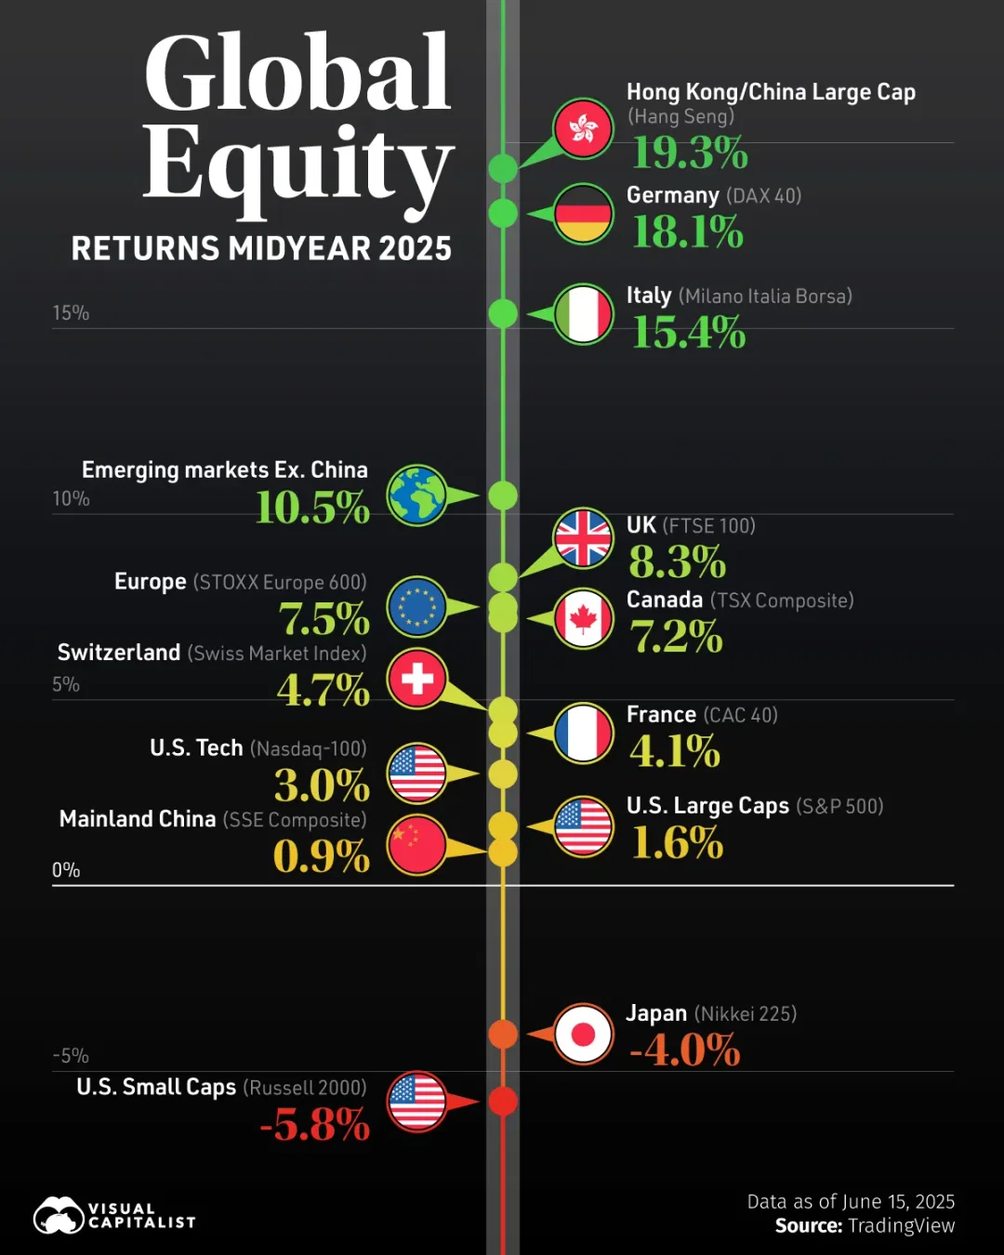

U.S. equities continue to see tepid returns in 2025, weighed down by a weak dollar and trade disruptions.
Instead, several global equity markets—from the Hang Seng Index to European stocks—are booming. While policy support in China is driving returns, massive defense spending is contributing to gains across German and Italian indices. This graphic shows year-to-date global equity returns, based on data from TradingView.

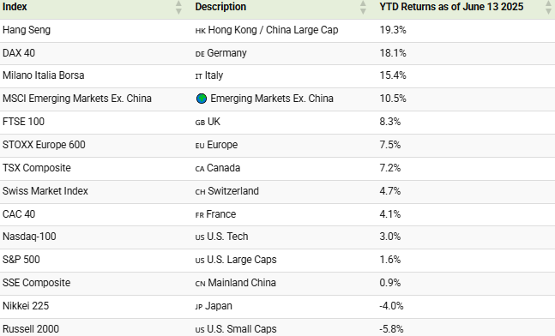

Key Insights:
As of June 13, 2025, the Hang Seng Index has returned 19.3%—the strongest returns across leading global equity markets While mainland China’s market remains sluggish, Hong Kong’s Hang Seng Index is surging, driven by investor optimism around DeepSeek.

Additionally, retail giant Shein is reportedly considering shifting its IPO from London, while battery maker CATL raised over $4 billion in an IPO in May. With U.S. markets seeing muted returns, the Hang Seng is positioning itself as the world’s top IPO destination in 2025.

Meanwhile, Germany’s DAX 40 Index is up 18.1%, aided by a 500-billion-euro infrastructure fund. Adding to this, falling inflation coupled with a strong euro are providing favorable conditions for interest rate cuts. Like Germany, Italy’s major index has seen strong gains of 15.4%.

With year-to-date returns of 7.1%, Canadian equities remain resilient despite the economy’s vulnerability to global trade tensions. This strength is likely due to its defensive sector mix, attractive valuations, and fear of fatigue of tariff tensions.

As we can see, U.S. markets have lagged in 2025—though some standout performers have emerged. Palantir leads the S&P 500 with a remarkable 82% return so far, while NRG Energy and Howmet Aerospace have each surged over 50%, driven by momentum in the AI and defense industries.

https://www.visualcapitalist.com/largest-u-s-companies-by-revenue-in-2025/#google_vignette
July 1, 2025

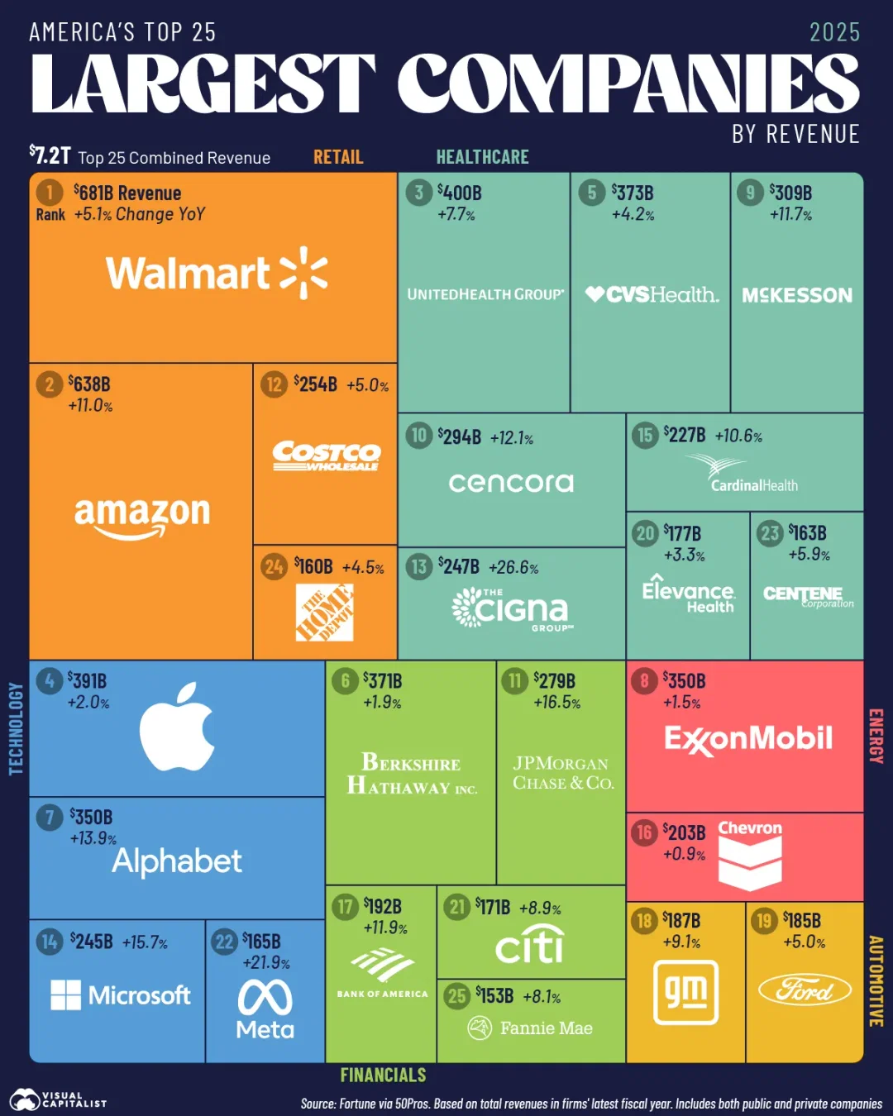

America’s top 25 firms by revenue generate more than $7 trillion in sales annually, often standing as the largest employers across states.
Overall, retail heavyweights Walmart and Amazon lead the pack, while five health care firms rank in the top 10. Although the rankings saw minimal change from 2024, Trump tariffs stand to shake up corporate America, with firms such as Apple and Ford revising profit forecasts looking ahead.
This graphic shows the largest U.S. companies by revenue, based on data from Fortune via 50Pros.

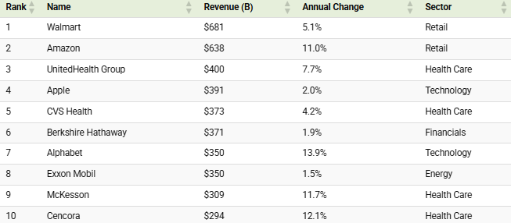

Key Insights:
With $681 billion in revenues, Walmart tops the rankings by a sizable margin.
Recently, its e-commerce business surpassed $100 billion in sales with approximately 12% of Americans saying thy have a Walmart+ subscription. In 2024, the value of this segment was roughly 20% of Amazon’s—up from about 10% in 2017.

While Amazon stands in second in the rankings, it boasts three times the profits of Walmart largely thanks to its cloud services division, Amazon Web Services (AWS). Despite generating just 16.9% of total revenues, AWS drives about 50% of the firms profits. Since 2023, the firm’s operating margin has expanded by 72%.

With $400 billion in revenues, UnitedHealth Group falls in third—exceeding giants like Apple and ExxonMobil. However, the company is facing multiple headwinds in 2025, including the resignation of its CEO and a criminal probe from the Justice Department into its Medicaid practices.
Given increased scrutiny, the company downgraded its 2025 earnings forecast as its share performance sharply underperforms its peers.

All index and returns data from Norgate Data and Commodity Systems Incorporated and Wall Street Journal

News from Reuters, Barron’s, Wall St. Journal, Bloomberg.com, ft.com, guggenheimpartners.com, zerohedge.com, ritholtz.com, markit.com, financialpost.com, Eurostat, Statistics Canada, Yahoo! Finance, stocksandnews.com, marketwatch.com, visualcapitalist.com, wantchinatimes.com, BBC, 361capital.com, pensionpartners.com, cnbc.com, FactSet, Morningstar/Ibbotson Associates, Corporate Finance Institute, Hubert Ratings.

Commentary from T Rowe Price Global markets weekly update — https://www.troweprice.com/personal-investing/resources/insights/global-markets-weekly-update

