

Forefront Asset Management, LLC Monthly Newsletter
Tuesday, June 10th, 2025
FOR MARKET CLOSE — June 9th, 2025

U.S. Equity Market Assessment and Economic Outlook

In the blink of an eye, the markets have rebounded with extraordinary momentum. The race to “buy the dip” has happened as fast the initial sell-off, which took place back in March/April timeframe. The question everyone is asking now is where do we go from here? Based on the move higher and everything that’s transpired, the odds favor new all-time highs and the resumption of the uptrend. Given the speed of the move upward we’ve just experienced, expect the markets to consolidate or pull back for a time before gaining internal energy for the next move higher. As of today, all three trends (short, intermediate and long) in the market are positive. This is clearly bullish market behavior despite negative macro trends (un-inversion of the yield curve, increased default rates on loans, weak housing market, etc.).

Market Technical Indicators

Long Term Bull-Bear Indicator (Years)

Status: POSITIVE

Quarterly Timeframe Indicator (Monthly to Quarterly)

Status: POSITIVE

Shorter Timeframe Indicator (Weeks to Months)

Status: POSITIVE

THE COMPLETE PICTURE // READING THE INDICATORS

THREE INDICATORS ACROSS THREE TIMEFRAMES

- Yearly Trend Indicator — Positive since 6/10/25
- Quarterly Trend Indicator— Positive since April 1st, 2023
- Short term Trend Indicator—Positive since May 12th, 2025

When ALL the indicators are POSITIVE, we read the market as being in a BULL MARKET STATUS.
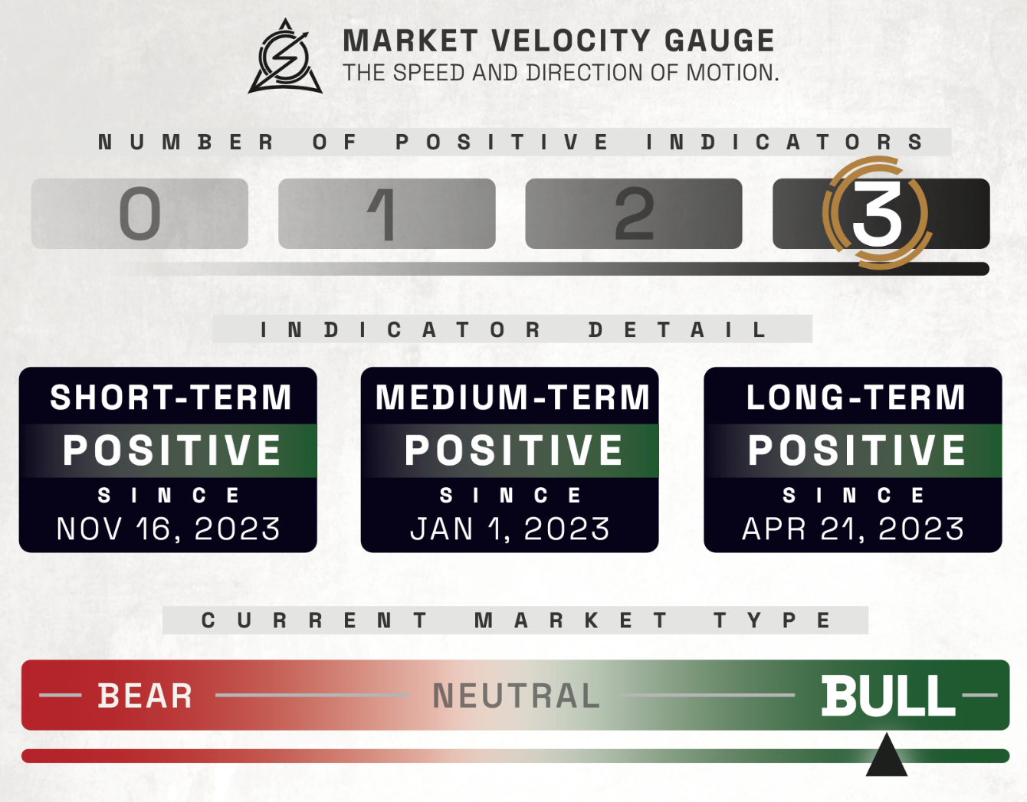

THIS MONTH’S ECONOMIC NEWS

U.S. MARKET OVERVIEW
Markets continue HIGHER
U.S. stocks continue to climb with small-cap stocks leading the gains as the Russell 2000 Index rose 3.19%, followed by the Nasdaq Composite up 2.18% and the Dow Jones Industrial Average up 1.17%, all joining the S&P 500 in positive territory for the year. Information technology stocks outperformed, buoyed by optimism around artificial intelligence (AI) following strong corporate earnings and news that Meta Platforms signed a 20-year deal with Constellation Energy to support its AI operations. Meanwhile, trade tensions between the U.S. and China resurfaced after social media comments from President Donald Trump, though a phone call between Trump and President Xi Jinping later in the week offered a more hopeful tone, with Trump describing the discussion as reaching “a very positive conclusion for both countries.” Even now, the trade talks continue into this week.

THIS MONTH’S ECONOMIC NEWS FOR THE US

Mixed economic Data:
May’s economic data offered a mixed but slightly more positive picture of the U.S. economy, with job growth slowing yet outperforming expectations and other indicators showing signs of strain. The Labor Department reported 139,000 new nonfarm payrolls in May—down from April’s revised 147,000 but above the forecasted 130,000—while the unemployment rate held steady at 4.2%. The upbeat jobs report, which followed weaker data from ADP and rising initial jobless claims, helped lift both stocks and Treasury yields. Meanwhile, job openings and hiring picked up in April, suggesting continued labor demand despite the start of broad tariffs under the Trump administration. However, manufacturing activity shrank for the third straight month, with the ISM PMI dropping to 48.5%—its lowest level since November—while services activity also unexpectedly contracted for the first time in nearly a year, registering a PMI of 49.9%. Despite falling demand, prices remained high in both sectors, and while new orders dropped sharply, service sector employment rebounded into expansion territory.

INTERNATIONAL MARKETS
Europe
The pan-European STOXX Europe 600 Index rose 0.90% in local currency terms, buoyed by slowing inflation, an interest rate cut from the European Central Bank (ECB), and strong U.S. jobs data that eased recession fears. Major European indexes also gained, with Germany’s DAX and Italy’s FTSE MIB both climbing 1.28%, France’s CAC 40 up 0.68%, and the UK’s FTSE 100 advancing 0.75%. The ECB cut its deposit rate by 25 basis points to 2%, marking the lowest level since 2022, and President Christine Lagarde signaled the rate-cutting cycle may be nearing its end, though future moves will depend on data. Meanwhile, eurozone GDP was revised sharply higher for Q1, growing 0.6%—its fastest pace since Q3 2022—driven by strong performances in Ireland and Germany. Inflation slowed to 1.9% in May, dipping below the ECB’s 2% target, while core inflation also declined. Despite these positive trends, Germany and France reported weaker-than-expected industrial output in April, each contracting by 1.4%, although German manufacturing orders beat expectations with a surprise increase.

Japan
Japan’s stock markets declined over the week, with the Nikkei 225 slipping 0.59% and the TOPIX Index falling 1.15%, as bilateral trade talks with the U.S. yielded no agreement but hinted at a potential deal announcement during the June G7 summit. The yen remained stable around JPY 144 per U.S. dollar, while the 10-year Japanese government bond yield dipped to 1.46% from 1.50%, following a recent spike driven by concerns over Japan’s fiscal health and speculation that the Bank of Japan (BoJ) may be tapering bond purchases too quickly. BoJ Governor Kazuo Ueda acknowledged general market support for tapering, though reports hinted that the central bank may consider slowing the pace next year. Economically, household spending disappointed with a 0.1% year-over-year decline in April, while real wages fell 1.8% as inflation outpaced wage growth. Despite these weak spots, the BoJ maintained that Japan’s economy is in a moderate recovery and reaffirmed its readiness to raise interest rates again if inflation and growth continue to meet projections, reinforcing expectations for a gradual policy tightening path.

China
Mainland Chinese stock markets rose over the week as a series of weaker-than-expected economic indicators fueled hopes for additional government stimulus, with the CSI 300 Index gaining 0.88% and the Shanghai Composite Index climbing 1.13% in local currency terms, while Hong Kong’s Hang Seng Index advanced 2.16%. A private survey revealed that China’s manufacturing sector experienced its steepest contraction since September 2022, with the Caixin manufacturing PMI falling to 48.3 in May from 50.4 in April—well below forecasts—largely due to the impact of U.S. tariffs on smaller exporters. However, the Caixin services PMI edged up to 51.1, signaling modest growth. These figures stood in contrast to slightly more positive official data released earlier, with the official manufacturing PMI improving to 49.5 in May from 49.0 in April, likely buoyed by a temporary 90-day tariff reduction agreement between China and the U.S. The official nonmanufacturing PMI dipped marginally to 50.3 from 50.4, reflecting continued softness in services and construction activity.

THIS MONTH’S HIGHLIGHTED STORY
https://www.visualcapitalist.com/u-s-manufacturing-by-state-who-gains-most-from-made-in-america/
June 6, 2025

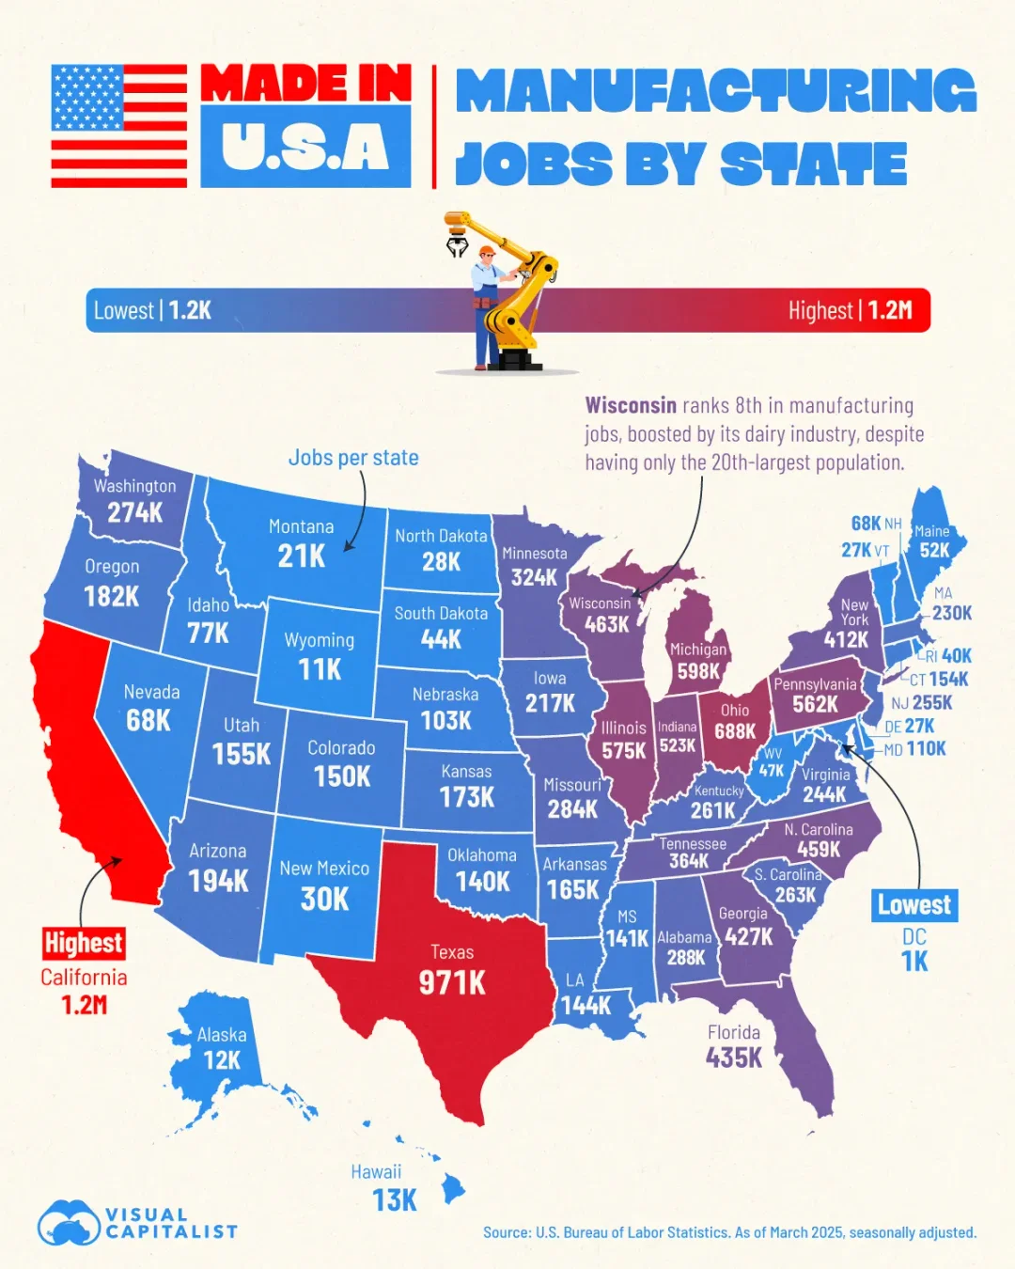

President Trump has championed the idea that a key part of making America great again is bringing back industries that left the country in recent decades. With his tariff-driven trade policy, the White House has promoted “Made in America” as a way to create jobs and boost the economy.
Based on April 2025 data from the Bureau of Labor Statistics, this map highlights the U.S. states leading and lagging in manufacturing employment.

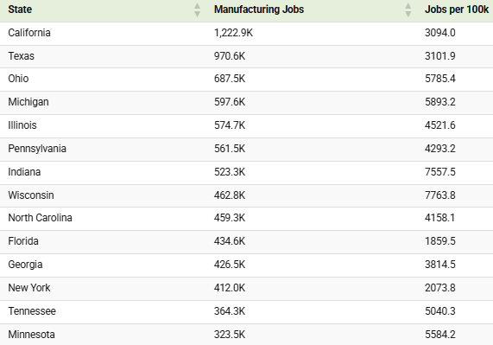

Key Insights:

Several Southern states have also built strong manufacturing bases. North Carolina (459,300), Georgia (426,500), and Tennessee (364,300) each rank among the top states, supported by industries such as automotive, aerospace, and food processing.
Wisconsin, ranked in the top 10 for total manufacturing employment, stands out for outperforming its size. Although it’s only the 20th most populous state, its manufacturing base remains strong, thanks in part to food and dairy processing. In per capita terms, it’s number one in the nation with 7,763.8 manufacturing jobs for every 100,000 people.
Florida, another top 10 state, has emerged as a growth story. Between 2019 and 2023, the state’s manufacturing employment grew by nearly 10%, highlighting the sector’s expansion in one of the country’s largest economies.
At the other end of the spectrum, Wyoming (10,600 jobs), Alaska (11,900), and Washington, D.C. (1,200) recorded the lowest levels of manufacturing employment. The latter (D.C.) also has the lowest numbers per capita.

All index and returns data from Norgate Data and Commodity Systems Incorporated and Wall Street Journal

News from Reuters, Barron’s, Wall St. Journal, Bloomberg.com, ft.com, guggenheimpartners.com, zerohedge.com, ritholtz.com, markit.com, financialpost.com, Eurostat, Statistics Canada, Yahoo! Finance, stocksandnews.com, marketwatch.com, visualcapitalist.com, wantchinatimes.com, BBC, 361capital.com, pensionpartners.com, cnbc.com, FactSet, Morningstar/Ibbotson Associates, Corporate Finance Institute, Hubert Ratings.

Commentary from T Rowe Price Global markets weekly update — https://www.troweprice.com/personal-investing/resources/insights/global-markets-weekly-update

